Decision Reviews Failure Emails to eFolder Initiative Brief

## Outcome Summary

BVA can consistently identify the decision review submission failure emails sent to Veterans’ eFolder in VBMS.

## Problem:

Today, the Board of Veterans Appeals does not have transparency into communications sent to Veterans after they submit a Board Appeal

## Failure Email example:

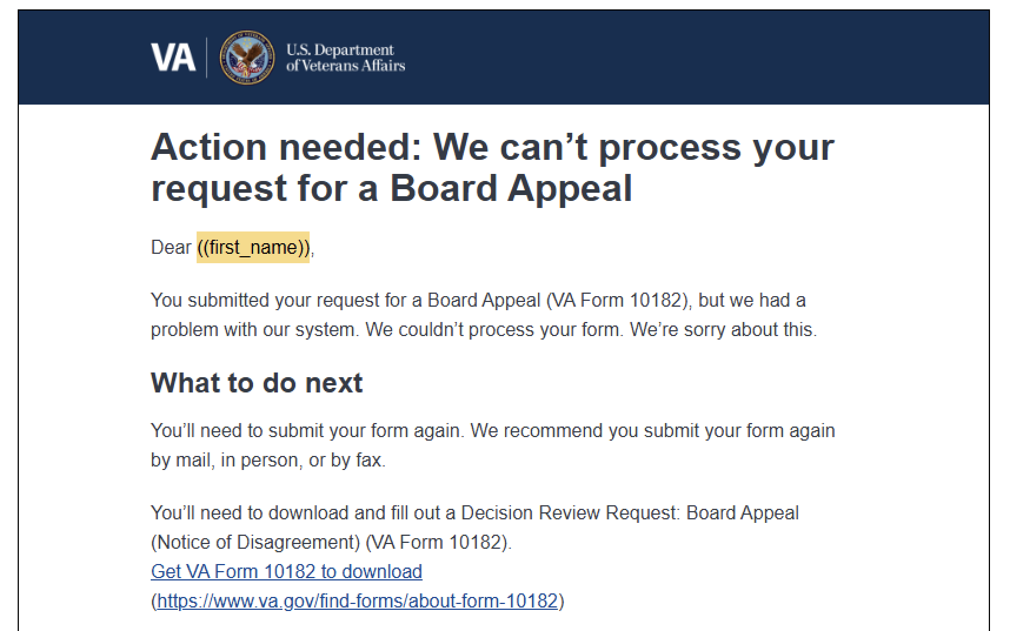

## Considerations:

* VA has approved of a PDF of the email we send
* VANotify may not give the option to download the emails we sent
  + Which means we can’t get a PDF of the email

PDF into VBMS:

* Skip CMS and direct into VBMS eFolder
* Integrate with Caseflow to do this?

## Possible next steps:

* Ask VANotify if they can provide us with an endpoint to obtain PDF of the sent failure emails
  + Our capabilities entirely depend on VANotify’s current feature set
  + Viewing their API documentation, there’s no body/content in the response
  + If they are able to oblige w this feature request, see what LOE and timeline would be
* Ask around VA VFS teams to see if anyone else does this and how they do it
  + We don’t currently believe any teams do it yet
* DR team to create the PDF ourselves of the failure email
  + Using the template and data shared with VANotify

## Target Audience:

BVA - Board of Veteran’s Appeals processors

## Audience:

## Desired User Outcomes

## Undesired User Outcomes

## Desired Business Outcomes

## Undesired Business Outcomes

* I

## 

## Risks

## Measuring Success

**Potential Key Performance Indicators (KPIs)**

## 

## Communications

Team Name: Benefits Decision Review

GitHub Label(s): Decision-Reviews-Team

Slack channel: benefits-decision-review

Product Owners: Amy Lai   
Product Manager: Maurice DeBeary